**UNO**

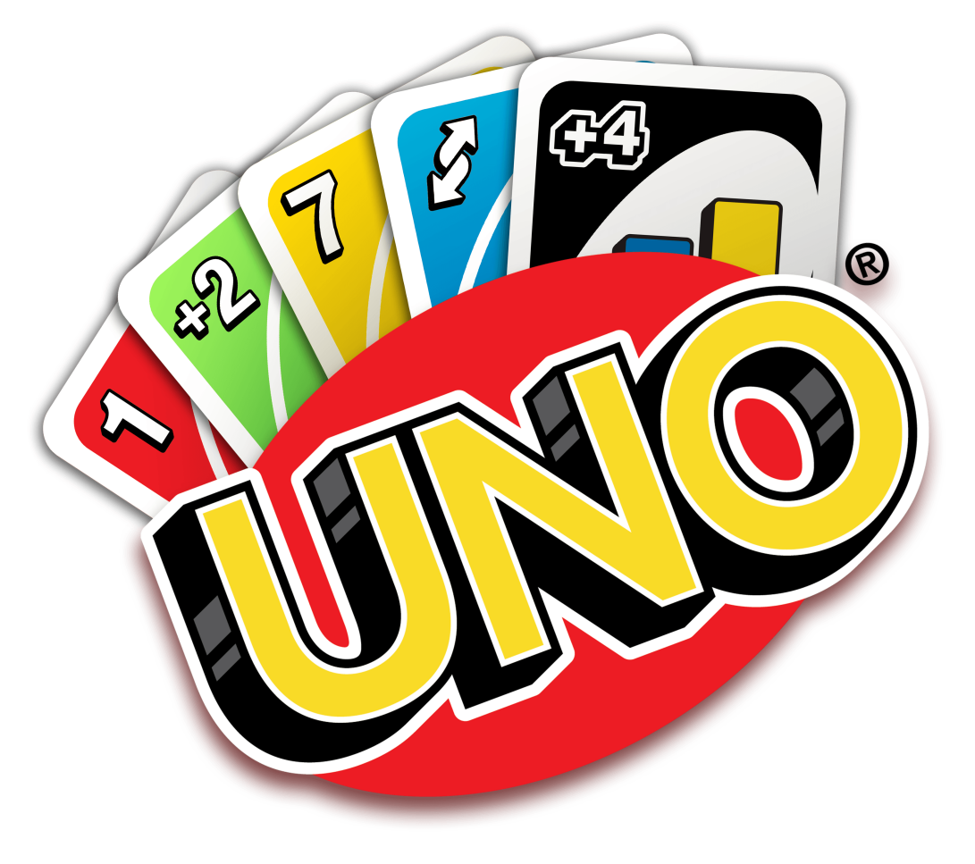

**Description:** A card game where players match cards by color or number.

**How to Play:** Players take turns matching cards in their hand with the card shown on top of the deck. Special action cards add to the fun.

**Location:** Indoor

**Things Needed:** UNO card deck

**Number of Players:** 2 to 10